Licensure of International Board Certified Lactation Consultants (IBCLCs):
Summary for Physicians
SENATE BILL 763: SUPPORT LICENSURE OF THE IBCLC

IBCLCS are collaborative members of the healthcare team whose professional Code of Conduct and Scope of Practice require accurate documentation and reporting to the primary healthcare provider.
We propose inclusion of documentation and reporting requirements from the IBLCE into the Nursing Board regulations for lactation consultants.
IBCLC licensure will increase access to the most qualified and vetted lactation care providers.
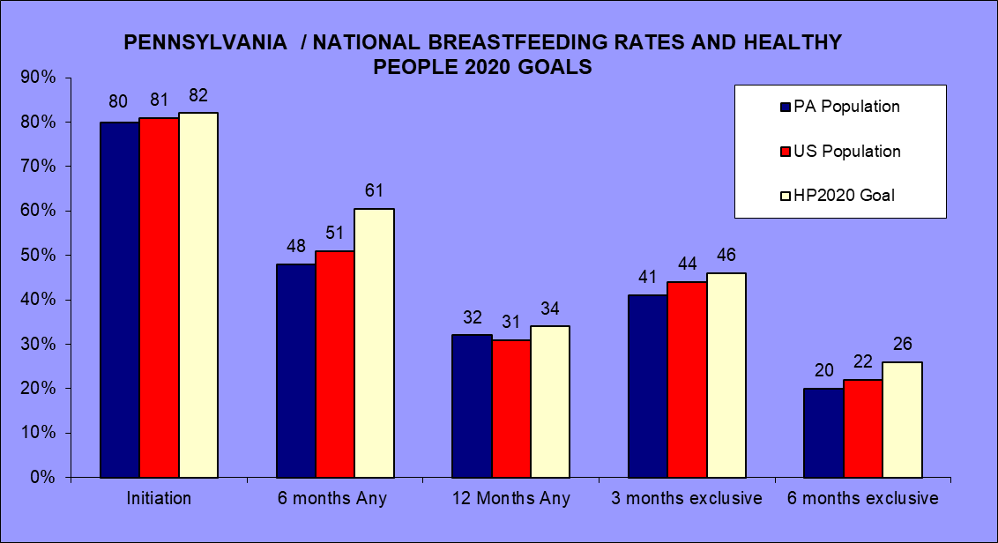
Poor duration rates signify the need for lactation support.
Breastfeeding families want and need professional lactation support as a standard of care in hospitals and after discharge.
IBCLCs offer evidence-based clinical lactation care to enable successful breastfeeding, fulfilling a public health imperative.
Figure 1 CDC Breastfeeding Report Card

IBCLCs can provide a valuable service for physicians, enhancing primary care services in the medical home.
- Licensure supports the integration of the IBCLC into a standard healthcare practice to prevent harm from poor feeding to safely maintain exclusive breastfeeding and to extend any breastfeeding.
- IBCLCs work collaboratively with physicians in hospitals, physician offices, clinics, private practices, WIC and public health settings and are required to document and report to the primary care providers.
- IBCLCs do not encroach on the scope of practice of physicians, nurses, midwives or any other licensed healthcare provider.
- Licensure of IBCLCs will enable physicians to direct-bill for lactation care in their offices, saving physician time and increasing profitability while improving patient satisfaction.
- IBCLC care may reduce sick visits, especially for feeding difficulties, thereby supporting capitation limits and facilitating the goals of high quality, cost-effective healthcare.
- Licensure by the state will identify a highly qualified lactation professional to alleviate physician concerns regarding negligent referral.
- State licensure meets insurer criteria and government regulations for provider credentialing.
- Third-party reimbursement facilitates racial and socioeconomic healthcare equity.
Breastfeeding problems persist and result in weaning without lactation care
✔ 80% of PA mothers want to breastfeed.
✔ 71% of mothers’ experience breastfeeding problems during their hospital stay.
✔ 92% of first-time mothers and 83% of ALL mothers have problems in the week after hospital discharge.
✔ 60% of mothers wean before meeting their own goals.
✔ Mothers without knowledgeable lactation support wean before they plan, depriving themselves and their
babies of the health benefits of breastfeeding and risking postpartum depression.

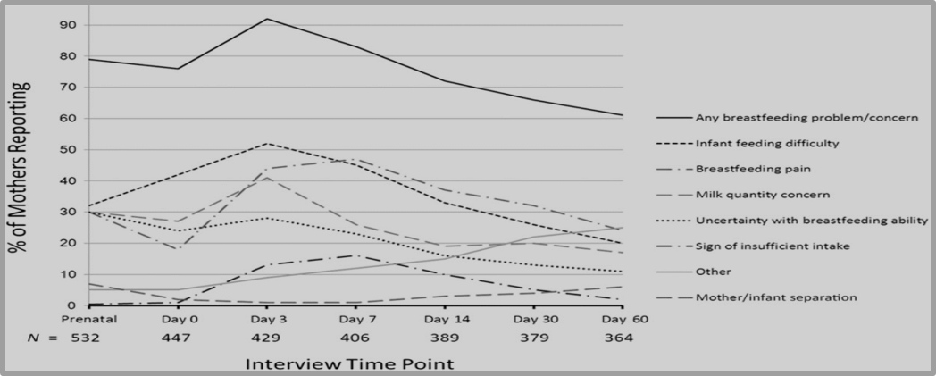
Figure 2 Erin A. Wagner et al. Pediatrics 2013;13: e865-e875 ©2013 by American Academy of Pediatrics
Just a few contacts with an IBCLC triples the likelihood of breastfeeding at one year.
Efficacy of the IBCLC to improve breastfeeding initiation, intensity and duration is established by over 40 studies available at: http://tinyurl.com/IBCLCefficacy

Licensure of the IBCLC within the Pennsylvania Nursing Board ensures rigorous preparation for professional and clinical lactation care, assured communication with the primary care team, and state oversight.

INTERNATIONAL BOARD CERTIFIED LACTATION CONSULTANT

SUPERIOR TRAINING, EDUCATION, EXPERTISE
These prerequisites are the most stringent in the lactation field.
- 90 hours of breastfeeding-specific education
- 14 college level health science courses
- 300-1000 clinical practice hours
- rigorous exam

UNIQUE APPROACH TO COMPLEX PROBLEMS
- evidence-based care
- prevent harm from inadequate feeding
- safe, individualized services

EMPOWERING WOMEN TO ACHIEVE THEIR BREASTFEEDING GOALS
Women have similar breastfeeding goals, but experience diverse hurdles.

For more information, please contact:
Healthy Keystone
Kids Initiative
Judith Gutowski
jlgutowski@comcast.ne
Cell: 724-331-6607
www.breastfeedpa.net

References available on our website for this publication.

International Board of Lactation Consultant Examiners (2015) Code of Professional Conduct for IBCLCs. https://iblce.org/wp-content/uploads/2017/05/code-of-professional-conduct.pdf International Board of Lactation Consultant Examiners (2012) Scope of Practice for International Board Certified Lactation Consultant (IBCLC) Certificants https://iblce.org/wp-content/uploads/2017/05/scope-of-practice.pdf
U.S. Lactation Consultant Association (2016) Who’s Who in Lactation: A glance at Lactation Support in the United States https://uslca.org/wp-content/uploads/2016/06/2-page-Whos-Who-watermark.pdf
Centers for Disease Control and Prevention (2016) Breastfeeding Report Card https://www.cdc.gov/breastfeeding/pdf/2016breastfeedingreportcard.pdf Chantry, CJ. (2011) Supporting the 75%: Overcoming Barriers After Breastfeeding Initiation. Breastfeeding Medicine, 6 (5)5, DOI: 10.1089/bfm.2011.0089, 337-339. www.ncbi.nlm.nih.gov/pmc/articles/PMC3192362/pdf/bfm.2011.0089.pdf Odom EC, Li R, Scanlon KS, Perrine CG, & Grummer-Strawn L. (2013) Reasons for Earlier Than Desired Cessation of Breastfeeding. Pediatrics; 131(3) e726-e732. http://pediatrics.aappublications.org/content/early/2013/02/13/peds.2012-1295 Perrine CG et al (2012) Baby-Friendly Hospital Practices and Meeting Exclusive Breastfeeding Intention. Pediatrics 130 (1) July. http://pediatrics.aappublications.org/content/early/2012/05/29/peds.2011-3633 Wagner, E.A., Chantry, C.J., Dewey, K.G., & Nommsen-Rivers, L.A. (2013) Breastfeeding Concerns at 3 and 7 Days Postpartum and Feeding Status at 2 Months. Pediatrics, Oct; 132 (4): e865-e875. http://pediatrics.aappublications.org/content/132/4/e865
Hartman, Rachel Rose (20150 I wish I didn’t have to rely on Google to help me breastfeed. The Guardian. https://www.theguardian.com/commentisfree/2015/may/01/i-wish-i-didnt-have-to-rely-on-google-to-help-me-breastfeed Rochman, Bonnie (2012) Why Most Moms Don’t Reach Their Own Breast-Feeding Goals Time: Family Matters http://healthland.time.com/2012/06/04/why-most-moms-cant-reach-their-own-breast-feeding-goals/?iid=sr-link3 Eisenberg, Staci R et al. (2015) Maternal Report of Advice Received for Infant Care. Pediatrics DOI: 10.1542/peds.2015-0551www.pediatrics.org/cgi/doi/10.1542/peds.2015-0551 Kaplan, K (2016) Too many mothers stop breastfeeding their babies too soon, and task force says doctors should do more to change that. Los Angeles Times http://www.latimes.com/science/sciencenow/la-sci-sn-breastfeeding-recommendations-20161025-snap-story.html Davis, Lisa Seslin (2013) Is the Medical Community Failing Breastfeeding Moms? Time http://healthland.time.com/2013/01/02/is-the-medical-community-failing-breastfeeding-moms/#ixzz2GvPVzUla Centers for Disease Control and Prevention (2016) CDC Winnable Battles Final Report. https://www.cdc.gov/winnablebattles/report/docs/winnable-battles-final-report.pdf Rollins, Nigel C. et al (2016) Why invest, and what it will take to improve breastfeeding practices? Lancet 387: 491-504 http://www.thelancet.com/journals/lancet/article/PIIS0140-6736(15)01044-2/abstract
U.S. Lactation Consultant Association (2017) Efficacy of the IBCLC https://uslca.org/wp-content/uploads/2016/07/Efficacy-of-the-IBCLC.pdf
American Academy of Pediatrics: Section on Breastfeeding (2012) Breastfeeding and the Use of Human Milk. Pediatrics 129(3). doi:10.1542/peds.2011-3552 Association of Women's Health, Obstetric and Neonatal Nurses (2011) Guidelines for Professional Registered Nurse Staffing for Perinatal Units Executive Summary. Journal of Obstetric, Gynecologic, & Neonatal Nursing, 40: 131–134. doi:10.1111/j.1552-6909.2010.01214.x Baby Friendly USA (2017) Individualized Care in the Baby-Friendly Hospital Initiative. https://d14abeop4cfxkt.cloudfront.net/cms/files/399/files/original/Individualized_Care_in_the_BFHI-Updated-170530.pdf Baby-Friendly USA. “Guidelines and Evaluation Criteria for Facilities Seeking Baby-Friendly Designation.” Albany, NY: Baby-Friendly USA, 2016. https://d14abeop4cfxkt.cloudfront.net/cms/files/386/files/original/GEC2016.pdf Bass JL, Gartley T, Kleinman R. (2016) Unintended Consequences of Current Breastfeeding Initiatives. JAMA Pediatr. 170(10):923-924. doi:10.1001/jamapediatrics.2016.1529 Berger-Larrañaga M, Bustamante-Abuid C, Díaz-Vergara S, Tresierra-Cabrera J, Mayta-Tristán P, R Segura E. (2015) Breastfeeding Problems and other Factors Associated with Excessive Neonatal Weight Loss in Social Security Hospital in Lima Peru. Nutr Hosp 32(5):2062-70. DOI: 10.3305/nh.2015.32.5.9462 Castillo-Hegyi, C. (2015) “Mothers deserve better”: An interview with Dr. Christie Del Castillo-Hegyi” http://www.fearlessformulafeeder.com/2015/05/interview-with-dr-christie-del-castillo-hegyi/ Castillo-Hegyi, C. (2015) Letter to Doctors and Parents about the Dangers of Insufficient Exclusive Breastfeeding https://fedisbest.org/2015/04/letter-to-doctors-and-parents-about-the-dangers-of-insufficient-exclusive-breastfeeding/ Chang RJ, Chou HC, Chang YH, Chen MH, Chen CY, Hsieh WS, Tsao PN. (2012) Weight loss percentage prediction of subsequent neonatal hyperbilirubinemia in exclusively breastfed neonates. Pediatr Neonatol. 53(1):41-4. doi: 10.1016/j.pedneo.2011.11.008. Chen, Chien-Fu et al. (2011) Influence of Breast-feeding on Weight Loss, Jaundice, and Waste Elimination in Neonates. Pediatrics & Neonatology 52 (2): 85-92. http://dx.doi.org/10.1016/j.pedneo.2011.02.010 Dewey KG, Nommsen-Rivers LA, Heinig MJ, Cohen RJ. (2003) Risk factors for suboptimal infant breastfeeding behavior, delayed onset of lactation, and excess neonatal weight loss. Pediatrics 112 (3Pt 1): 607-19. DOI: 10.1542/peds.112.3.607 Escobar GJ, Gonzales VM, Armstrong MA, Folck BF, Xiong B, Newman TB. (2002) Rehospitalization for Neonatal DehydrationA Nested Case-Control Study. Arch Pediatr Adolesc Med. 156(2):155-161. doi:10.1001/archpedi.156.2.155 Furman LM, Banks EC, North AB. (2013) Breastfeeding among high-risk inner-city African-American mothers: a risky choice? Breastfeed Med. (1):58-67. doi: 10.1089/bfm.2012.0012. Grossman X1, Chaudhuri JH, Feldman-Winter L, Merewood A. (2012) Neonatal weight loss at a US Baby-Friendly Hospital. J Acad Nutr Diet. 112(3):410-3. doi: 10.1016/j.jada.2011.10.024. Huang, Hsin-Chung et al. (2012) Model to Predict Hyperbilirubinemia in Healthy Term and Near-Term Newborns with Exclusive Breast Feeding Pediatrics & Neonatology 53 (6): 354 – 358. 10.1016/j.pedneo.2012.08.012 Hurst. Nancy M. Recognizing and Treating Delayed or Failed Lactogenesis II (2007) J Midwifery Women’s Health. 52(6):588-594. DOI: 10.1016/j.jmwh.2007.05.005 Iyer NP1, Srinivasan R, Evans K, Ward L, Cheung WY, Matthes JW (2008) Impact of an early weighing policy on neonatal hypernatraemic dehydration and breast feeding. Arch Dis Child. 93(4):297-9. Epub 2007 May 2. http://adc.bmj.com/content/93/4/297.long Jurkowski JM, Svistova J, Nguyen T, Dennison BA. (2016) Public Reporting of Hospital-Specific Breastfeeding Measures. J Hum Lact. 2016 Nov;32(4):666-674. doi: 10.1177/0890334416663197. Konetzny, G., Bucher, H.U. & Arlettaz, R. Eur J Pediatr (2009) Prevention of hypernatraemic dehydration in breastfed newborn infants by daily weighing. 168: 815. doi:10.1007/s00431-008-0841-8 Kudumula V, Asokkumar A, Akinsoji O, et al. (2009) Breastfeeding malnutrition in neonates: a step towards controlling the problem. Archives of Disease in Childhood 94:246. DOI: 10.1136/adc.2008.148510 Laing, I., & Wong, C. (2002). Hypernatraemia in the first few days: is the incidence rising? Archives of Disease in Childhood Fetal and Neonatal Edition, 87(3), F158–F162. http://doi.org/10.1136/fn.87.3.F158 Manganaro R, Mamì C, Marrone T, Marseglia L, Gemelli M. (2001) Incidence of dehydration and hypernatremia in exclusively breast-fed infants. J Pediatr. 139(5):673-5. http://dx.doi.org/10.1067/mpd.2001.118880 Meek, Joan Younger, Lawrence Noble. (2016) Implementation of the Ten Steps to Successful Breastfeeding Saves Lives. JAMA Pediatr. 170(10):925-926. doi: 10.1001/jamapediatrics.2016.2015 Moritz, ML ((2013) Preventing breastfeeding-associated hypernatraemia: an argument for supplemental feeding. Arch Dis Child Fetal Neonatal Ed. 98(5):F378-9. doi: 10.1136/archdischild-2013-303898. Moritz ML, Manole MD, Bogen DL, Ayus JC. (2005) Breastfeeding-associated hypernatremia: are we missing the diagnosis? Pediatrics 116(3):e343-7.DOI: 10.1542/peds.2004-2647 Oddie S, Richmond S, Coulthard M. (2001) Hypernatraemic dehydration and breast feeding: a population study. Arch Dis Child. 2001 Oct;85(4):318-20. doi: 10.1136/adc.85.4.318 Seske LM, SL Merhar & BE Haberman (2015) Late-Onset Hypoglycemia in Term Newborns with Poor Breastfeeding. Hospital Pediatrics 5(9). http://hosppeds.aappublications.org/content/5/9/501.long Straňák, Z., Feyereislova, S., Černá, M., Kollárová, J., & Feyereisl, J. (2016). Limited Amount of Formula May Facilitate Breastfeeding: Randomized, Controlled Trial to Compare Standard Clinical Practice versus Limited Supplemental Feeding. PLoS ONE, 11(2), e0150053. http://doi.org/10.1371/journal.pone.0150053 Unal S, Arhan E, Kara N, Uncu N, Aliefendioğlu D. (2008) Breast-feeding-associated hypernatremia: retrospective analysis of 169 term newborns. Pediatr Int. 50(1):29-34. doi: 10.1111/j.1442-200X.2007.02507.x. Young PC1, Korgenski K, Buchi KF. (2013) Early Readmission of Newborns in a Large Health Care System. Pediatrics 131(5):e1538-44. doi: 10.1542/peds.2012-2634
Chetwynd, E., Meyer, A., Stuebe, A., Costello, R., Labbock, M. (2013) Recognition of International Board Certified Lactation Consultants by the Health Insurance Providers in the United States. (2013) Journal of Human Lactation 29: 517-526. Retrieved from http://jhl.sagepub.com/content/early/2013/08/20/0890334413499974.abstract
International Board of Lactation Consultant Examiners (2012) Scope of Practice for International Board Certified Lactation Consultant (IBCLC) Certificants https://iblce.org/wp-content/uploads/2017/05/scope-of-practice.pdf
Witt AM, Smith S, Mason MJ, et al. (2011) “Integrating Routine Lactation Consultant Support into a Pediatric Practice”, Breastfeed Med. https://www.ncbi.nlm.nih.gov/pmc/articles/PMC3579324/
Bartick, Melissa (2017) Personal Communication. Computation of Pennsylvania data from published study of national data from 2016. Bartick, M. C., Schwarz, E. B., Green, B. D., Jegier, B. J., Reinhold, A. G., Colaizy, T. T., Bogen, D. L., Schaefer, A. J., and Stuebe, A. M. (2017) Suboptimal breastfeeding in the United States: Maternal and pediatric health outcomes and costs, Maternal & Child Nutrition, 13, e12366. doi: 10.1111/mcn.12366. http://onlinelibrary.wiley.com/doi/10.1111/mcn.12366/full
International Board of Lactation Consultant Examiners (2016-17) Candidate Information Guide https://iblce.files.wordpress.com/2017/05/candidate-information-guide-english.pdf
Federal Trade Commission (2014) March 20, 2014 Workshop: Examining Health Care Competition. https://www.ftc.gov/news-events/audio-video/workshops/2014-workshops
Madden, S. (2014) How to Appropriately Code and Bill for Lactation Services in Every Setting. United States Lactation Consultant Association Webinar for the U.S. Lactation Consultant Association
National Women’s Law Center (2014) Toolkit- New Benefits for Breastfeeding Moms: Facts and Tools to Understand Your Coverage under the Health Care Law. https://www.nwlc.org/sites/default/files/pdfs/final_nwlcbreastfeedingtoolkit2014_edit.pdf
PA Department of Health (2017) Breastfeeding Initiation Rates 2003-2015. Bureau of Family Health Breastfeeding Awareness and Support Program http://www.health.pa.gov/My%20Health/Womens%20Health/Breastfeeding%20Awareness/Pages/Data.aspx#.WbnY1-LD_c
Francis-Clegg, S., Francis D.T. & Intermountain Healthcare Lactation Standardization Project 2007 (2011) Improving the “Bottom-Line”: Financial Justification for the Hospital-Based Lactation Consultant Role. Clinical Lactation 2(1) 19-25
Chantry, CJ. (2011) Supporting the 75%: Overcoming Barriers After Breastfeeding Initiation. Breastfeeding Medicine, 6 (5)5, DOI: 10.1089/bfm.2011.0089, 337-339. www.ncbi.nlm.nih.gov/pmc/articles/PMC3192362/pdf/bfm.2011.0089.pdf Odom EC, Li R, Scanlon KS, Perrine CG, & Grummer-Strawn L. (2013) Reasons for Earlier Than Desired Cessation of Breastfeeding. Pediatrics; 131(3) e726-e732. http://pediatrics.aappublications.org/content/early/2013/02/13/peds.2012-1295 Perrine CG et al (2012) Baby-Friendly Hospital Practices and Meeting Exclusive Breastfeeding Intention. Pediatrics 130 (1) July. http://pediatrics.aappublications.org/content/early/2012/05/29/peds.2011-3633 Wagner, E.A., Chantry, C.J., Dewey, K.G., & Nommsen-Rivers, L.A. (2013) Breastfeeding Concerns at 3 and 7 Days Postpartum and Feeding Status at 2 Months. Pediatrics, Oct; 132 (4): e865-e875. http://pediatrics.aappublications.org/content/132/4/e865
Odom, EC, L Ruowei, KS Scanlon, CG Perrine & L Grummer-Strawn (2013) Reasons for Earlier Than Desired Cessation of Breastfeeding. Pediatrics DOI: 10.1542/peds.2012-1295
Krol, K.M., P. Rajhans, M. Missana & T Grossman (2015) Duration of exclusive breastfeeding is associated with differences in infants’ brain responses to emotional body expressions. Front Beh Neuro. Kendall-Tackett, K.A. (2007) A new paradigm for depression in new mothers: the central role of inflammation and how breastfeeding and anti-inflammatory treatments protect maternal mental health. J Hum Lact
U.S. Lactation Consultant Association (2017) Efficacy of the IBCLC. https://uslca.org/wp-content/uploads/2016/07/Efficacy-of-the-IBCLC.pdf
International Board of Lactation Consultant Examiners (2016-7) Candidate Information Guide https://iblce.files.wordpress.com/2017/05/candidate-information-guide-english.pdf Dahlquist N, Rosqvist JL. Lactation support in a busy pediatric practice: who pays the price? [Abstract 8]. Breastfeed Med 2007, 2:180.

